UDEMY ONLINE COURSES ANALYSIS

This analysis aims to dive deep into Udemy and uncover insights about what courses are most preferrable and what you need to be doing!

Exploratory data analysis

1. Data cleaning and preparation.
   1. Descriptive statistics

|  |
| --- |
| Data columns (total 12 columns): |
| # Column Non-Null Count Dtype |
| --- ------ -------------- ----- |
| 0 course_id 3678 non-null int64 |
| 1 course_title 3678 non-null object |
| 2 url 3678 non-null object |
| 3 is_paid 3678 non-null bool |
| 4 price 3678 non-null int64 |
| 5 num_subscribers 3678 non-null int64 |
| 6 num_reviews 3678 non-null int64 |
| 7 num_lectures 3678 non-null int64 |
| 8 level 3678 non-null object |
| 9 content_duration 3678 non-null float64 |
| 10 published_timestamp 3678 non-null object |
| 11 subject 3678 non-null object |
| dtypes: bool(1), float64(1), int64(5), object(5) |

The dataset has 11 columns which are categorized into different types. i.e Object, bool(true or false), int64(integers) and float(decimals).

Missing values: The dataset had no missing values.

|  |
| --- |
| course_id 0 |
| course_title 0 |
| url 0 |
| is_paid 0 |
| price 0 |
| num_subscribers 0 |
| num_reviews 0 |
| num_lectures 0 |
| level 0 |
| content_duration 0 |
| published_timestamp 0 |
| subject 0 |

Duplicate rows: The dataset had 8 duplicates which I removed using the drop duplicates feature.

1. Data visualization

**Course Popularity and Trends**

1. Most popular course

* The graph below shows the 5 top popular courses by number of subscribers. The most popular course is Learn HTML5 Programming from scratch which is a $75 dollar all level web development course with over 250,000 subscribers.

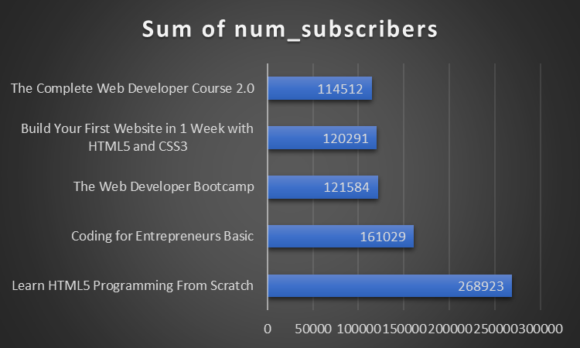

1. Most taught subject

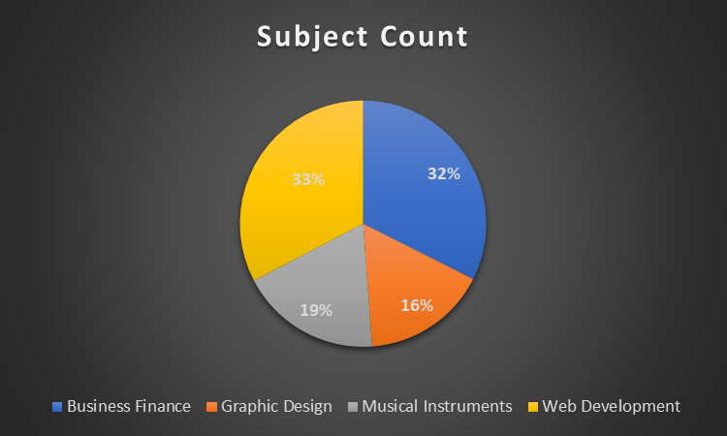

The most common subject in Udemy is Web Development with 33% of the total subjects and it is closely followed by Business Finance.

Level of expertise of courses offered in Udemy:

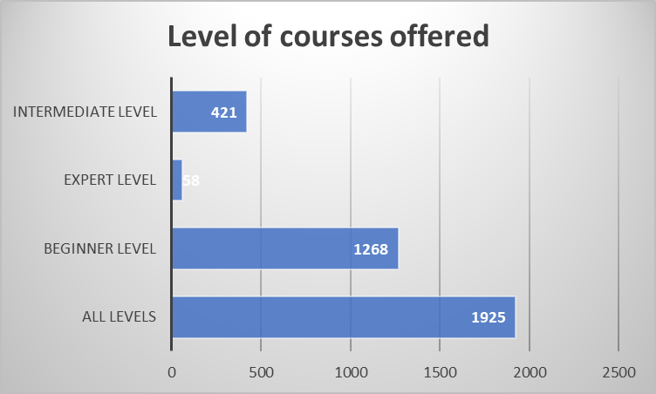

Udemy offers a wide range of course levels beginning from a beginner level all the way to expertise. However, most of their courses are for all levels which means that irregardless of your expertise in the subject, you can still take the course. The second most popular level are beginner-level courses, which means that beginners should also consider Udemy.

Number of reviews:

Lecturer distribution:

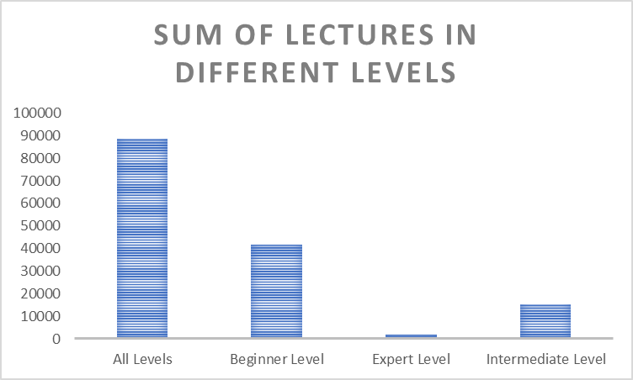

A large number of lecturers are available for the all level courses followed by beginner levels.